1. Create the three tables with their SQL queries and paste the code in text format below. Make sure while creating the tables: [5+2.5+2.5]

• Must have primary keys in all the tables.

• The attributes which can potentially be foreign keys must have NOT NULL Constraint.

• Gender attribute in users table should CHECK for ‘M’ or ‘F’.

Users Table Query :

CREATE TABLE users(

user_id serial PRIMARY KEY,

user_name VARCHAR(255),

age INT,

gender CHAR(1) CHECK(gender = 'M' OR gender = 'F'),

occ_id INT NOT NULL REFERENCES occupation(occ_id),

city_id INT NOT NULL REFERENCES city(city_id)

);

Occupation Table Query :

CREATE TABLE occupation (

occ_id INT NOT NULL PRIMARY KEY,

occ_name VARCHAR(255)

);

City Table Query:

CREATE TABLE city(

city_id INT NOT NULL PRIMARY KEY,

city_name VARCHAR(255)

);

(b) Write 2 different types of sql queries to find the users in city ‘Boston’.

Write 2 types of queries, one using joins to find the answer and another using subqueries to find the same answer.

ANS: USING JOINS:

SELECT users.user_id , users.user_name

FROM users JOIN city

ON city.city_id = users.city_id

WHERE city.city_name= 'Boston';

USING Sub-query:

SELECT user_id , user_name

FROM users

WHERE city_id = (SELECT city_id FROM city WHERE city_name = 'Boston');

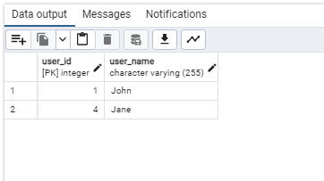

Write sql query to find how many users are there per occupation.

ANS:

SELECT occupation.occ_id, COUNT(users.user_id)

FROM users RIGHT JOIN occupation ON users.occ_id = occupation.occ_id

GROUP BY occupation.occ_id;

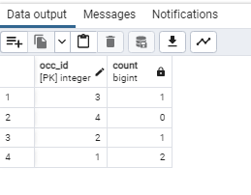

Perform full outer join between users and city

ANS:

SELECT *

FROM users FULL OUTER JOIN city

ON users.city_id = city.city_id;

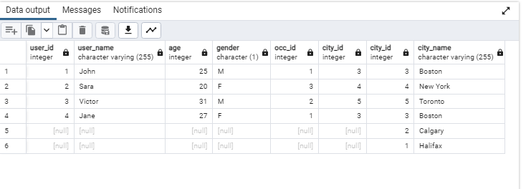

(c)

Write query to make a copy of ‘users’ table known as ‘users_new’ without Data.

ANS:

CREATE TABLE users_new

AS TABLE users

WITH NO DATA ;

Write query to insert all columns of ‘users’ to the ‘users_new’.

ANS:

INSERT INTO users_new

SELECT * FROM users;

Write CASE query to add one more column with salary values to the ‘users’ table. Salary for Software engineer is 80,000, Accountant is 70,000 and Pharmacist is 90,000.

ANS:

ALTER TABLE users_new

ADD salary NUMERIC(10,2);

UPDATE users_new

SET salary =

CASE

WHEN users_new.occ_id = (SELECT occ_id FROM occupation WHERE occ_name = 'Software engineer ')THEN 80000

WHEN users_new.occ_id = (SELECT occ_id FROM occupation WHERE occ_name = 'Accountant') THEN 70000

WHEN users_new.occ_id = (SELECT occ_id FROM occupation WHERE occ_name = 'Pharmacist')THEN 90000

END;